w2036476_7BUIS010W_CW1

1.

i.

**Relational Schema:**

* Citizen (citizenId, name, surname, gender, dateOfBirth, weight, height, phone number, address, districtId)
* Time (dateId, date, yearId, monthId, weekId, dayOfWeekId)
* Quarantine (quarantineId, quarantineName, numberOfDays)
* Vaccine (vaccineId, vaccineName)
* HealthUnit (healthUnitId, healthUnitName, address, districtId)
* DiseaseVariant (diseaseVariantId, diseaseId, variantName)
* PatientStatus (patientStatusId, patientStatusName)
* Drug (drugId, drugName, forDisease)
* Venue (venueId, venueType, venueAddress)
* DiseaseCase(patientId, citizenId, diseaseVariantId, patientStatusId, healthUnitId)

**Potential Fact Table:**

* VenueCases(venueId, dateId, patientId, vaccineId, quarantineId, drugId)

Comments:

* Every patient represents a disease case
* Based on the requirements the venue is for the quarantine and treatment of COVID-19

ii.

**Attribute Tree:**

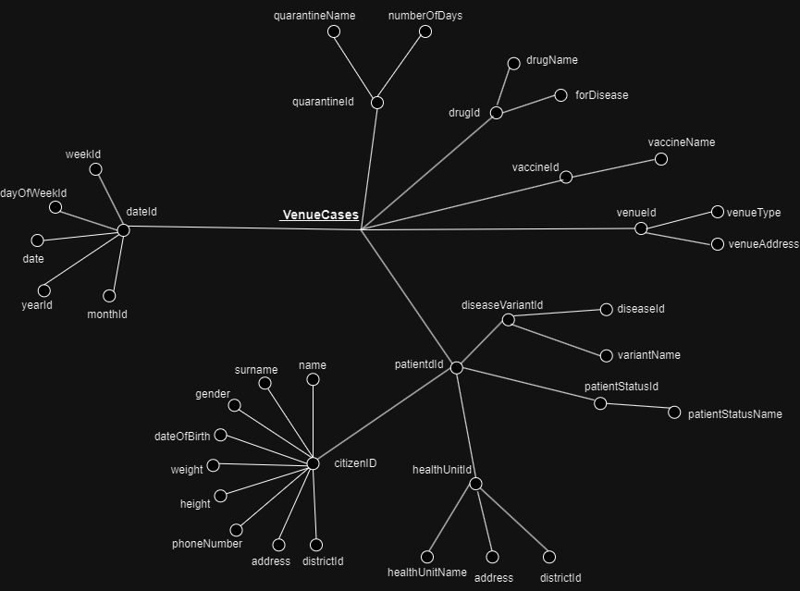

**Attribute Tree 2:**

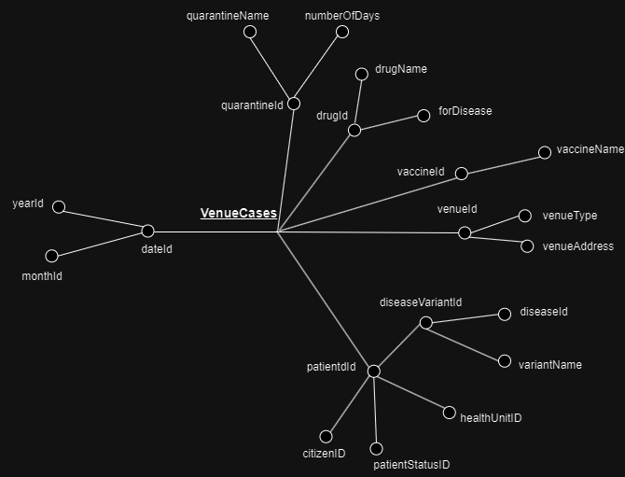

iii.

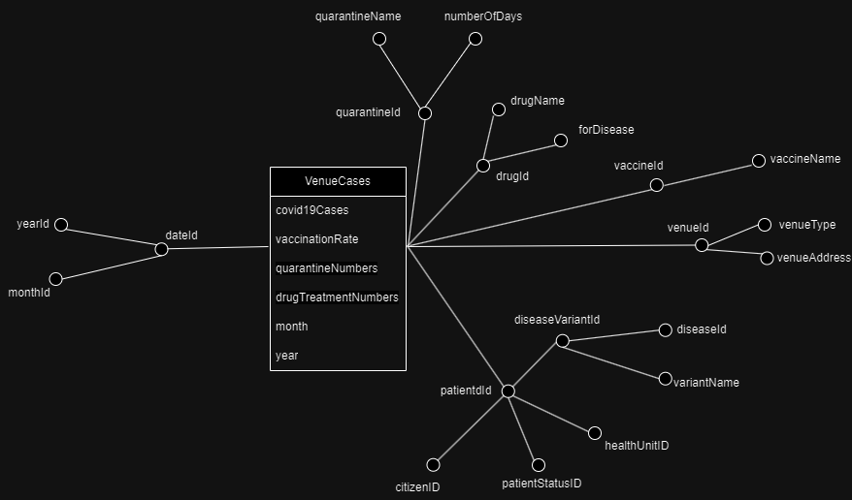

2.

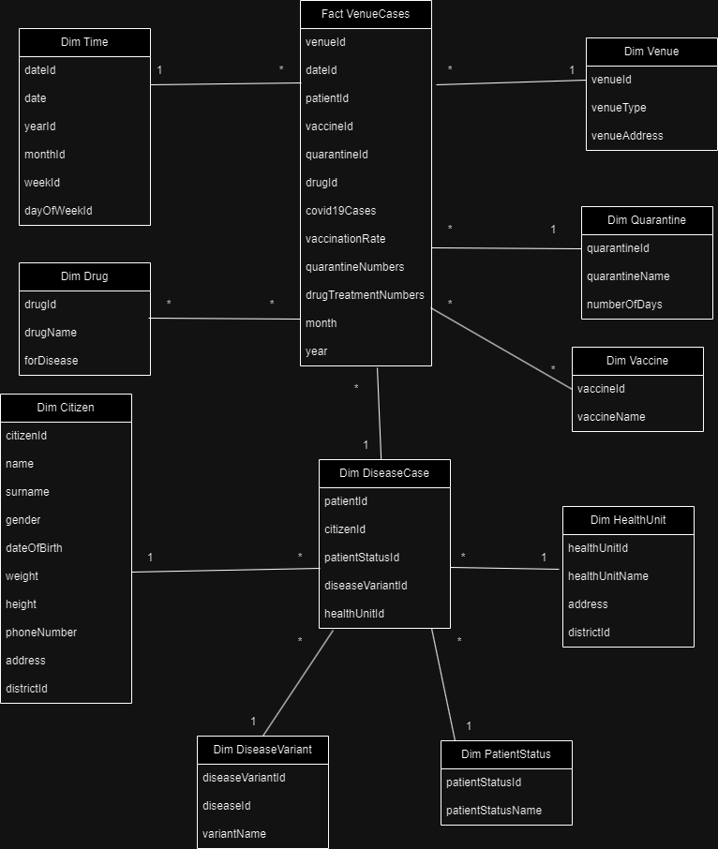

Comments:

* Depending on the case a patient may have multiple vaccinations and use multiple drugs
* Given the specification, it is assumed that the vaccines and drugs are given at the venue rather than the health unit

3.

**Working Data Warehouse Schema:**



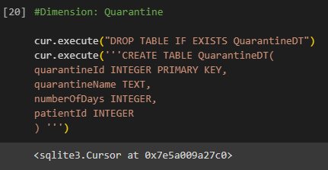

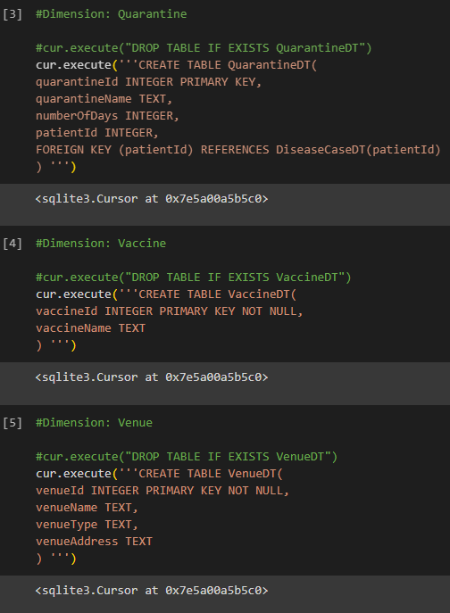

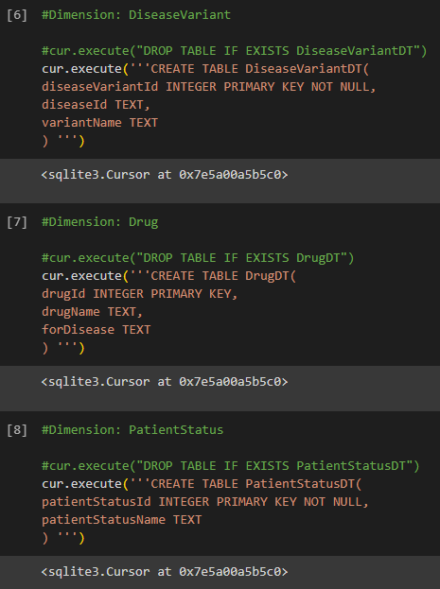

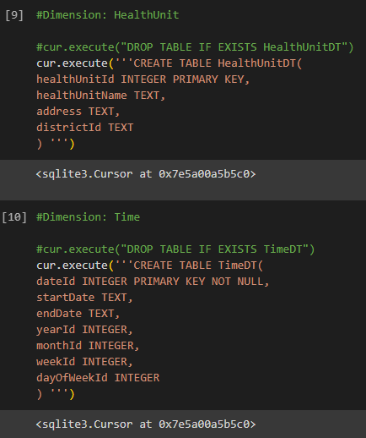

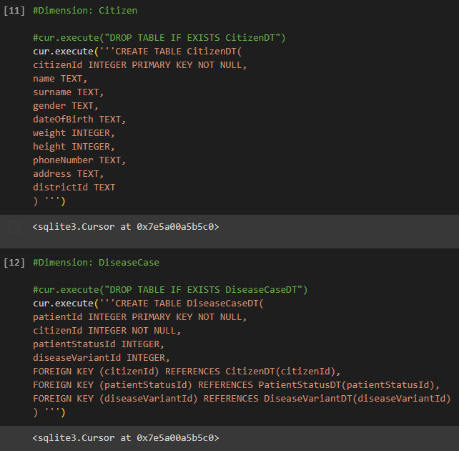

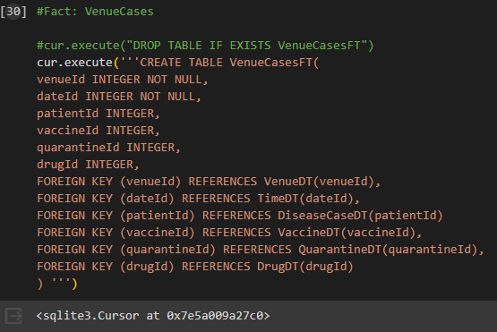

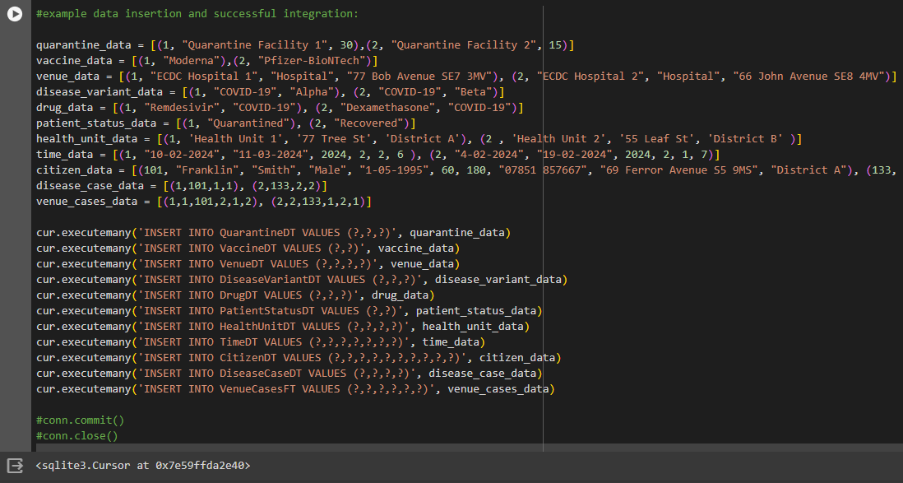

4.

**Fact Table Size:**

2 rows x 6 columns

**Matrix Specification:**

| **Queries** | **GROUP BY clause** | **FROM clause** | **SELECT clause** |
| --- | --- | --- | --- |
| Q1 | venueId, month | VenueCasesFT, TimeDT | venueId, month, covid19cases, vaccinationRate, quarantineNumbers,drugTreatmentNumbers |
| Q2 | month | m1 | month, covid19cases, quarantineNumbers, drugTreatmentNumbers |

One materialised view would be convenient to improve the response time of the frequent queries. Query 1 will be defined as a Materialised View, as Query 1 contains Query 2.

5.

i.

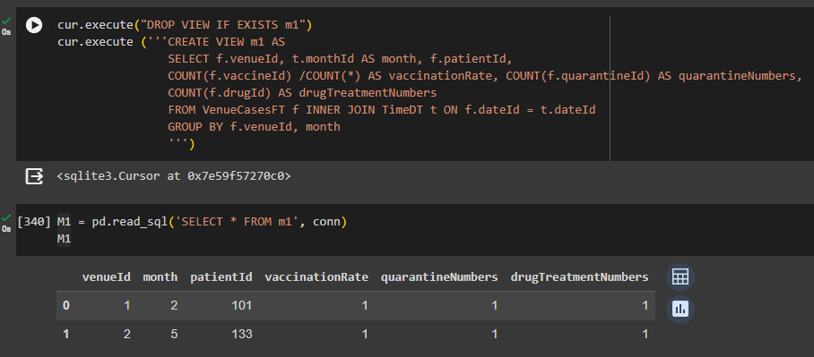

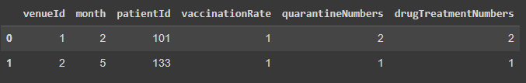

To check if the query worked with better examples, data was changed and more data was inserted:











ii.

